Фамилия переводчика ________________
Направление перевода: английский->русский
Предметная область: Авто

Примечание 1: Необходимо сделать перевод приведенного ниже фрагмента текста.
Примечание 2: Перевод текста размещается под оригиналом.

Оригинал:

- WORK OUTLINE
Check the serial number of the brake actuator, and if it is applicable, replace the brake actuator with a new one.

- PRECAUTIONS FOR BRAKE ACTUATOR REMOVAL/INSTALLATION
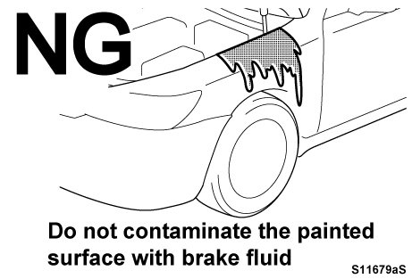 | - HANDLING OF BRAKE FLUID  - Do not allow brake fluid to come into contact with any painted body surface. Failure to do so could cause damage to the painted surface. If contact occurs, immediately rinse it off.

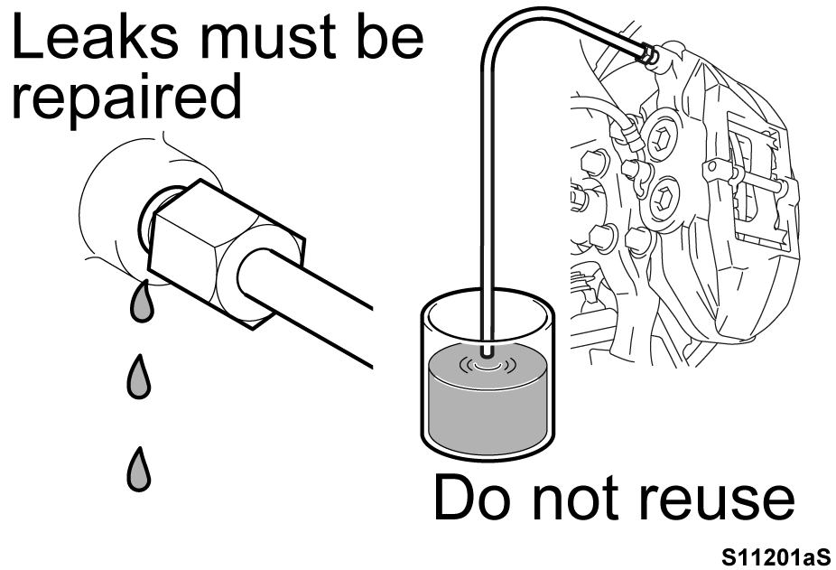 | - Do not reuse brake fluid. Brake fluid which has absorbed moisture or mineral oil may suffer significant degradation in quality or the condition of rubber seals, resulting in a potentially serious failure which may cause an accident.  - If any brake fluid leakage is found, it must be repaired.

    - Wear protective glasses when bleeding air as this may cause brake fluid to spray outwards.

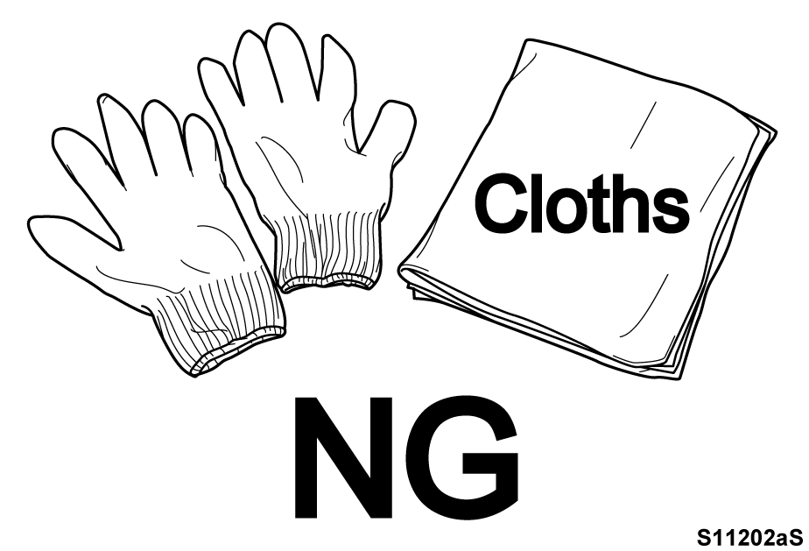 | - DO NOT USE CLOTH RAGS OR GLOVES  - Do not use any cloths or fabric gloves so as to prevent threads and fibers from entering the brake system.  - Keep your hands clean during work to prevent the entry of foreign objects into the components.

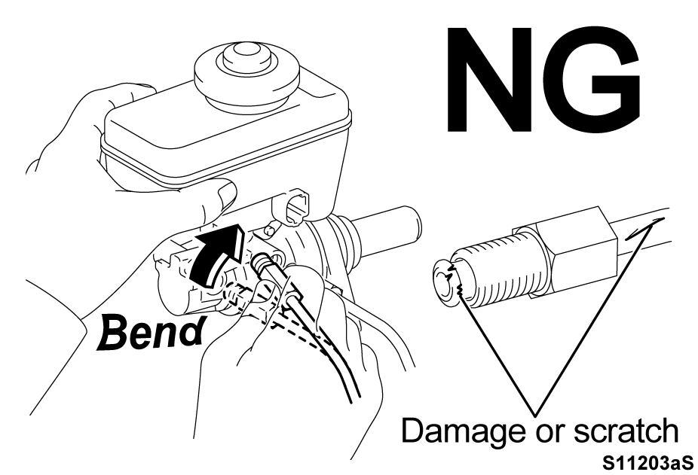 | - HANDLING OF BRAKE TUBES  - Be careful not to damage or deform the brake tubes during removal and reinstallation.

    - Do not twist, bend or let the brake tubes interfere with other parts while performing the work.
- CHECK SERIAL NUMBER OF BRAKE ACTUATOR ASSEMBLY
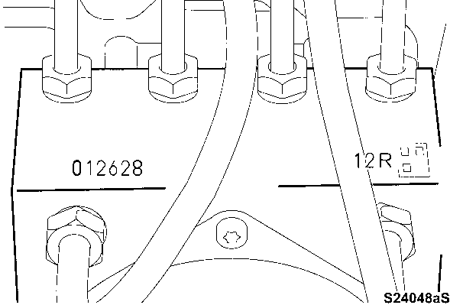 | - CHECK SERIAL NUMBERS  - Read the 3-digit and 6-digit serial numbers located on the areas shown in the illustration by a technician and a foreman / another technician. And read serial numbers are crosschecked, and if any digit is different, the serial number should be reconfirmed until same result. The following is the procedure to read the serial number.  - Take the photo of serial number by digital camera or smart phone, etc.  Note: Illuminate brake actuator with sufficient light at taking the photo.  - Install the photo of serial number in the personal computer and print out the photo copy of the serial number that is enlarged, and judge NG or OK.  Note: The attachment-1 is a sample of  the check sheet.

Перевод:
Введите текст перевода.

